K.Vasudeva Reddy
192411256
INTERNET PROGRAMING-CSA43

LAB PROGRAMS

1ST PROGRAM
<!DOCTYPE html>
<html lang="en">
<head>
<meta charset="UTF-8">
<meta name="viewport" content="width=device-width, initial-scale=1.0">
<title>Library Management System</title>

<style>
body{
background:linear-gradient(135deg,#eef2ff,#dbeafe,#f0fdf4);
min-height:100vh;
}

header{
background:linear-gradient(90deg,#4f46e5,#06b6d4);
color:white;
padding:18px 60px;
display:flex;
justify-content:space-between;
align-items:center;
box-shadow:0 4px 15px rgba(0,0,0,0.15);
}

nav a{
color:white;
text-decoration:none;
margin-left:25px;
font-weight:600;
transition:0.3s;
}

nav a:hover{
color:#ffeb3b;
}

.hero{
text-align:center;
padding:100px 20px;
background:linear-gradient(rgba(20,20,40,0.7),
rgba(20,20,40,0.7)),
url('https://images.unsplash.com/photo-1512820790803-83ca734da794?auto=format&fit=crop&w=1600&q=80');
background-size:cover;
background-position:center;
color:white;
}

.hero h2{
font-size:55px;
margin-bottom:20px;
}

.hero p{
font-size:20px;
max-width:700px;
margin:auto;
margin-bottom:30px;
}

.btn{
background:linear-gradient(90deg,#8b5cf6,#06b6d4);
color:white;
padding:14px 30px;
border-radius:30px;
text-decoration:none;
display:inline-block;
margin:10px;
font-weight:bold;
transition:0.3s;
}

.btn:hover{
transform:translateY(-3px);
box-shadow:0 8px 20px rgba(0,0,0,0.2);
}

.search-section{
padding:70px 20px;
text-align:center;
}

.search-box input{
width:350px;
padding:14px;
border:none;
border-radius:30px;
box-shadow:0 4px 12px rgba(0,0,0,0.1);
}

.search-box button{
padding:14px 25px;
border:none;
border-radius:30px;
background:#4f46e5;
color:white;
cursor:pointer;
margin-left:10px;
}

.features{
display:flex;
justify-content:center;
flex-wrap:wrap;
gap:25px;
padding:60px 30px;
}

.card{
width:280px;
background:rgba(255,255,255,0.75);
backdrop-filter:blur(10px);
border-radius:20px;
padding:30px;
text-align:center;
transition:0.3s;
box-shadow:0 8px 25px rgba(0,0,0,0.08);
}

.card:hover{
transform:translateY(-10px);
}

.card h3{
color:#4f46e5;
margin-bottom:15px;
}

.about{
margin:40px;
background:white;
border-radius:20px;
padding:60px;
text-align:center;
box-shadow:0 5px 20px rgba(0,0,0,0.08);
}

.about h2{
color:#4f46e5;
margin-bottom:15px;
}

footer{
background:linear-gradient(90deg,#4f46e5,#06b6d4);
color:white;
text-align:center;
padding:25px;
}
</style>
</head>

<body>

<header>
<h1> Library Management System</h1>

<nav>
<a href="#">Home</a>
<a href="login.html">Login</a>
<a href="register.html">Register</a>
<a href="#">Contact</a>
</nav>
</header>

<section class="hero">
<h2>Welcome to Digital Library</h2>
<p>Search books, borrow books, check fines and download study materials.</p>

<button type="button" onclick="window.location.href='login.html'" class="btn">
Login
</button>
<a href="register.html" class="btn">Register</a>
</section>

<section class="search-section">
<h2>Search Books</h2>

<div class="search-box">
<input type="text" placeholder="Enter Book Name">
<button>Search</button>
</div>
</section>

<section class="features">
<div class="card">
<h3> Book Catalog</h3>
<p>Search and view available books.</p>
</div>

<div class="card">
<h3> Borrow History</h3>
<p>Track issued and returned books.</p>
</div>

<div class="card">
<h3> Study Materials</h3>
<p>Download semester-wise materials.</p>
</div>

<div class="card">
<h3> Fine Management</h3>
<p>Check fines and return status.</p>
</div>
</section>

<section class="about">
<h2>About Library</h2>
<p>
This Library Management System helps students and librarians
manage books, borrowing records, fines, and study materials.
</p>
</section>

<footer>
<p>© 2026 Library Management System | All Rights Reserved</p>
</footer>
<script>
function login() {
let role = document.getElementById("role").value;

if(role === "admin") {
window.location.href = "admin.html";
} else {
window.location.href = "user.html";
}
}
</script>
</body>
</html>

OUT PUT:

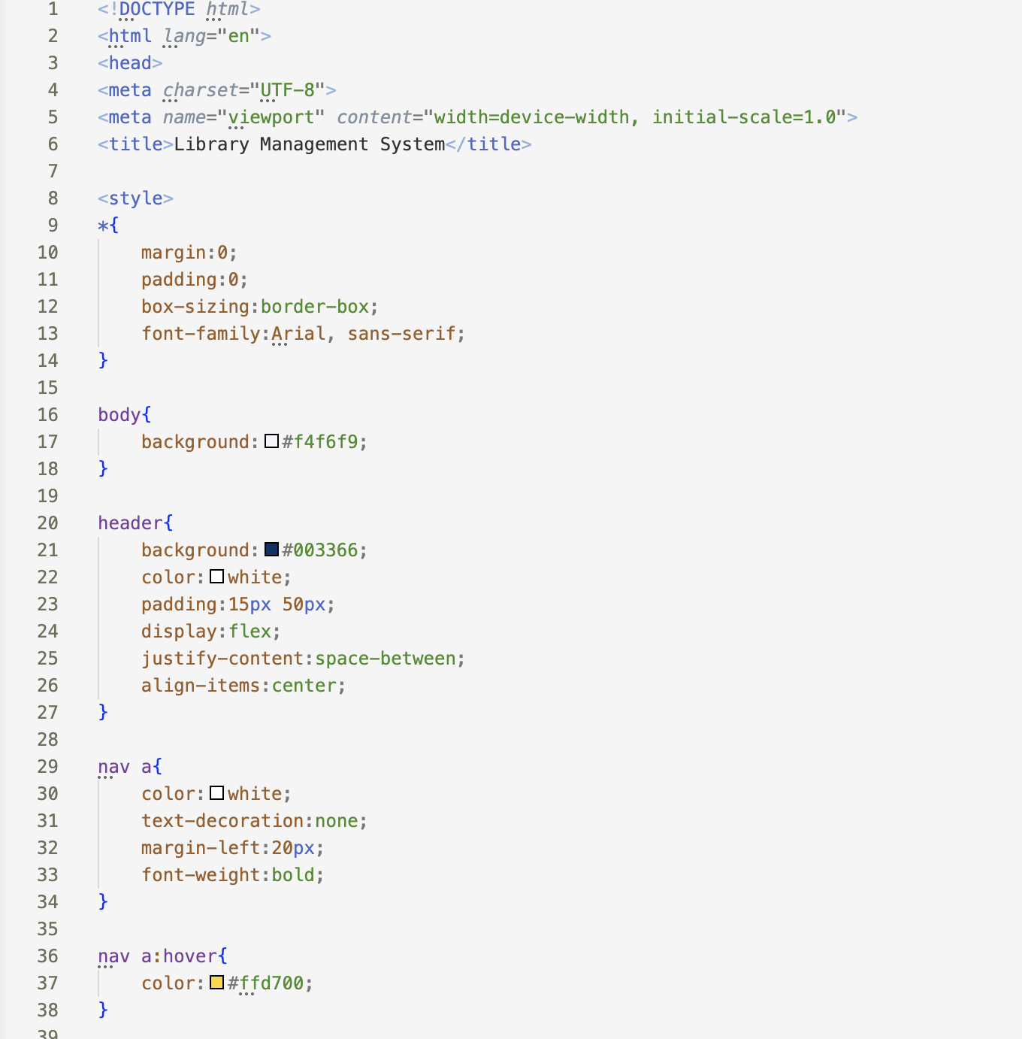 | 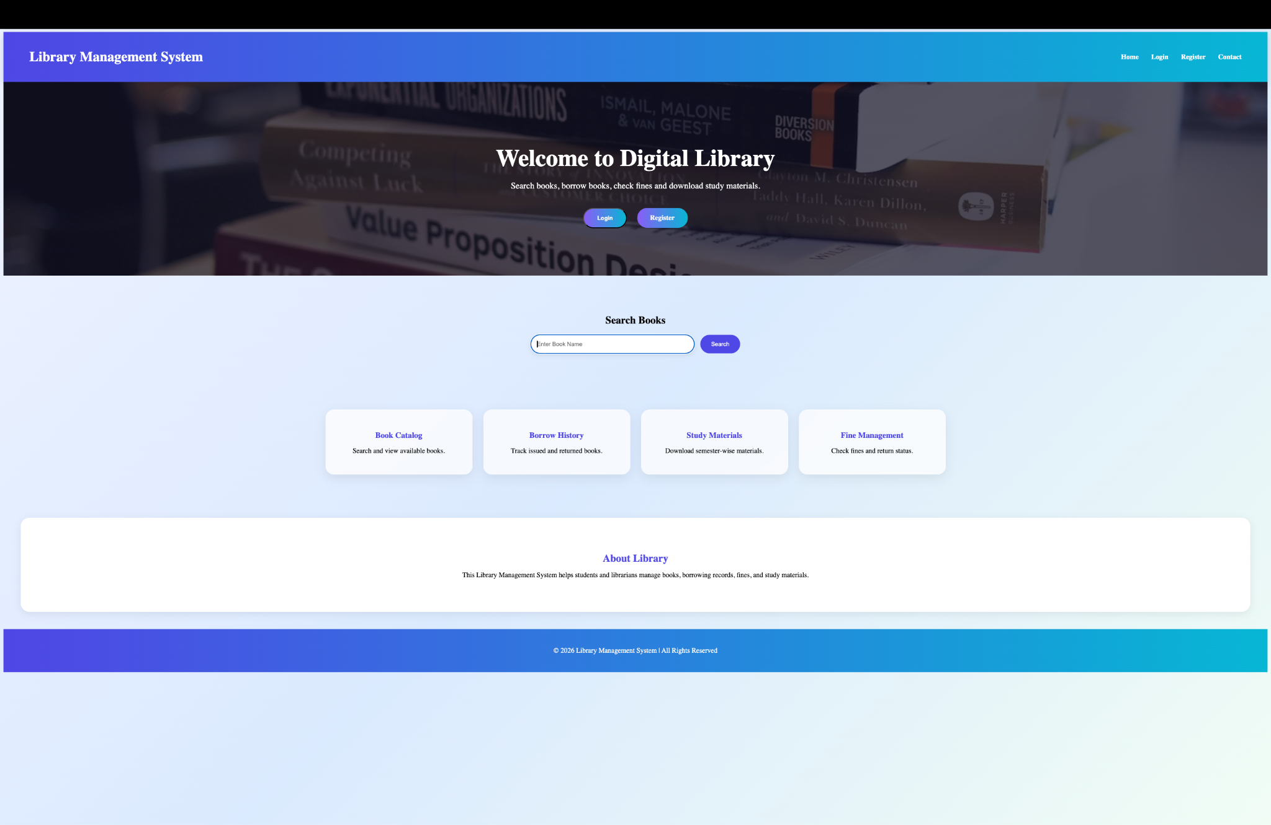

Experiment-2:
<!DOCTYPE html>
<html lang="en">
<head>
<meta charset="UTF-8">
<meta name="viewport" content="width=device-width, initial-scale=1.0">
<title>Skyline Resort Booking</title>

<style>

*{
margin:0;
padding:0;
box-sizing:border-box;
font-family:'Segoe UI',sans-serif;
}

body{
background:linear-gradient(135deg,#f5f7fa,#e4ecf7);
color:#333;
}

header{
background:linear-gradient(90deg,#6a11cb,#2575fc);
color:white;
padding:20px;
text-align:center;
box-shadow:0 4px 15px rgba(0,0,0,0.15);
}

header h1{
font-size:38px;
}

nav{
background:white;
padding:18px;
text-align:center;
box-shadow:0 2px 10px rgba(0,0,0,0.08);
}

nav a{
text-decoration:none;
color:#444;
margin:0 18px;
font-weight:600;
transition:0.3s;
}

nav a:hover{
color:#6a11cb;
}

.hero{
background:
linear-gradient(rgba(20,20,40,0.55),
rgba(20,20,40,0.55)),
url("https://images.unsplash.com/photo-1582719508461-905c673771fd?auto=format&fit=crop&w=1600&q=80");
background-size:cover;
background-position:center;
height:500px;
display:flex;
justify-content:center;
align-items:center;
text-align:center;
color:white;
}

.hero h1{
font-size:55px;
margin-bottom:10px;
}

.hero p{
font-size:20px;
}

.search-box{
background:white;
width:92%;
max-width:1100px;
margin:-60px auto 40px;
padding:25px;
border-radius:20px;
box-shadow:0 10px 30px rgba(0,0,0,0.15);
}

.search-box form{
display:grid;
grid-template-columns:repeat(auto-fit,minmax(180px,1fr));
gap:15px;
}

input,select{
padding:14px;
border:1px solid #ddd;
border-radius:10px;
font-size:15px;
}

button{
border:none;
border-radius:10px;
background:linear-gradient(90deg,#6a11cb,#2575fc);
color:white;
padding:14px;
font-size:16px;
cursor:pointer;
transition:0.3s;
}

button:hover{
transform:translateY(-3px);
}

.section{
padding:60px 40px;
}

.section h2{
text-align:center;
color:#6a11cb;
margin-bottom:35px;
}

.cards{
display:flex;
flex-wrap:wrap;
justify-content:center;
gap:25px;
}

.card{
width:290px;
background:white;
border-radius:20px;
overflow:hidden;
box-shadow:0 8px 25px rgba(0,0,0,0.1);
transition:0.3s;
}

.card:hover{
transform:translateY(-8px);
}

.card img{
width:100%;
height:200px;
object-fit:cover;
}

.card-content{
padding:18px;
}

.card h3{
margin-bottom:10px;
color:#2575fc;
}

.price{
color:#6a11cb;
font-size:20px;
font-weight:bold;
margin:10px 0;
}

.about-box,
.service-box,
.contact-box{
background:white;
max-width:1100px;
margin:auto;
padding:30px;
border-radius:20px;
box-shadow:0 5px 20px rgba(0,0,0,0.08);
}

.service-box ul{
list-style:none;
}

.service-box li{
padding:10px 0;
font-size:17px;
}

.contact-box p{
margin:12px 0;
}

footer{
background:linear-gradient(90deg,#6a11cb,#2575fc);
color:white;
text-align:center;
padding:25px;
margin-top:40px;
}

</style>
</head>

<body>

<header>
<h1>Skyline Resort Booking</h1>
<p>Luxury Experiences & Premium Stays</p>
</header>

<nav>
<a href="#">Home</a>
<a href="#">Suites</a>
<a href="#">Packages</a>
<a href="#">Gallery</a>
<a href="#">Contact</a>
<a href="#">Sign In</a>
</nav>

<div class="hero">
<div>
<h1>Escape To Paradise</h1>
<p>Discover luxury stays with breathtaking views</p>
</div>
</div>

<div class="search-box">
<form>
<input type="text" placeholder="Where are you going?">
<input type="date">
<input type="date">
<select>
<option>1 Adult</option>
<option>2 Adults</option>
<option>3 Adults</option>
<option>4 Adults</option>
</select>
<button type="submit">Find Rooms</button>
</form>
</div>

<section class="section">

<h2>Popular Accommodations</h2>

<div class="cards">

<div class="card">
<img src="https://images.unsplash.com/photo-1566665797739-1674de7a421a?auto=format&fit=crop&w=800&q=80">
<div class="card-content">
<h3>Ocean View Room</h3>
<p>Modern room with sea-facing balcony.</p>
<div class="price">$99 / Night</div>
<button>Reserve</button>
</div>
</div>

<div class="card">
<img src="https://images.unsplash.com/photo-1590490360182-c33d57733427?auto=format&fit=crop&w=800&q=80">
<div class="card-content">
<h3>Premium Deluxe</h3>
<p>Luxury king-size suite with breakfast.</p>
<div class="price">$149 / Night</div>
<button>Reserve</button>
</div>
</div>

<div class="card">
<img src="https://images.unsplash.com/photo-1584132967334-10e028bd69f7?auto=format&fit=crop&w=800&q=80">
<div class="card-content">
<h3>Executive Villa</h3>
<p>Private villa with premium facilities.</p>
<div class="price">$249 / Night</div>
<button>Reserve</button>
</div>
</div>

<div class="card">
<img src="https://images.unsplash.com/photo-1578683010236-d716f9a3f461?auto=format&fit=crop&w=800&q=80">
<div class="card-content">
<h3>Family Residence</h3>
<p>Spacious rooms for family vacations.</p>
<div class="price">$299 / Night</div>
<button>Reserve</button>
</div>
</div>

</div>

</section>

<section class="section">
<div class="about-box">
<h2>Why Choose Skyline Resort?</h2>
<p>
Experience comfort, elegance, and world-class hospitality.
Our platform allows guests to explore premium accommodations,
secure bookings instantly, and enjoy unforgettable vacations.
</p>
</div>
</section>

<section class="section">
<div class="service-box">
<h2>Guest Benefits</h2>

<ul>
<li>✓ Flexible Reservation Options</li>
<li>✓ Instant Online Confirmation</li>
<li>✓ Exclusive Member Discounts</li>
<li>✓ 24/7 Concierge Assistance</li>
<li>✓ Secure Payment Gateway</li>
</ul>

</div>
</section>

<section class="section">
<div class="contact-box">
<h2>Reach Us</h2>

<p>📧 reservations@skyline-resort.com</p>
<p>📞 +1 (800) 555-2026</p>
<p>📍 Beachfront Avenue, Miami, Florida</p>

</div>
</section>

<footer>
<p>© 2026 Skyline Resort Booking. All Rights Reserved.</p>
</footer>

</body>
</html>

OUTPUT :
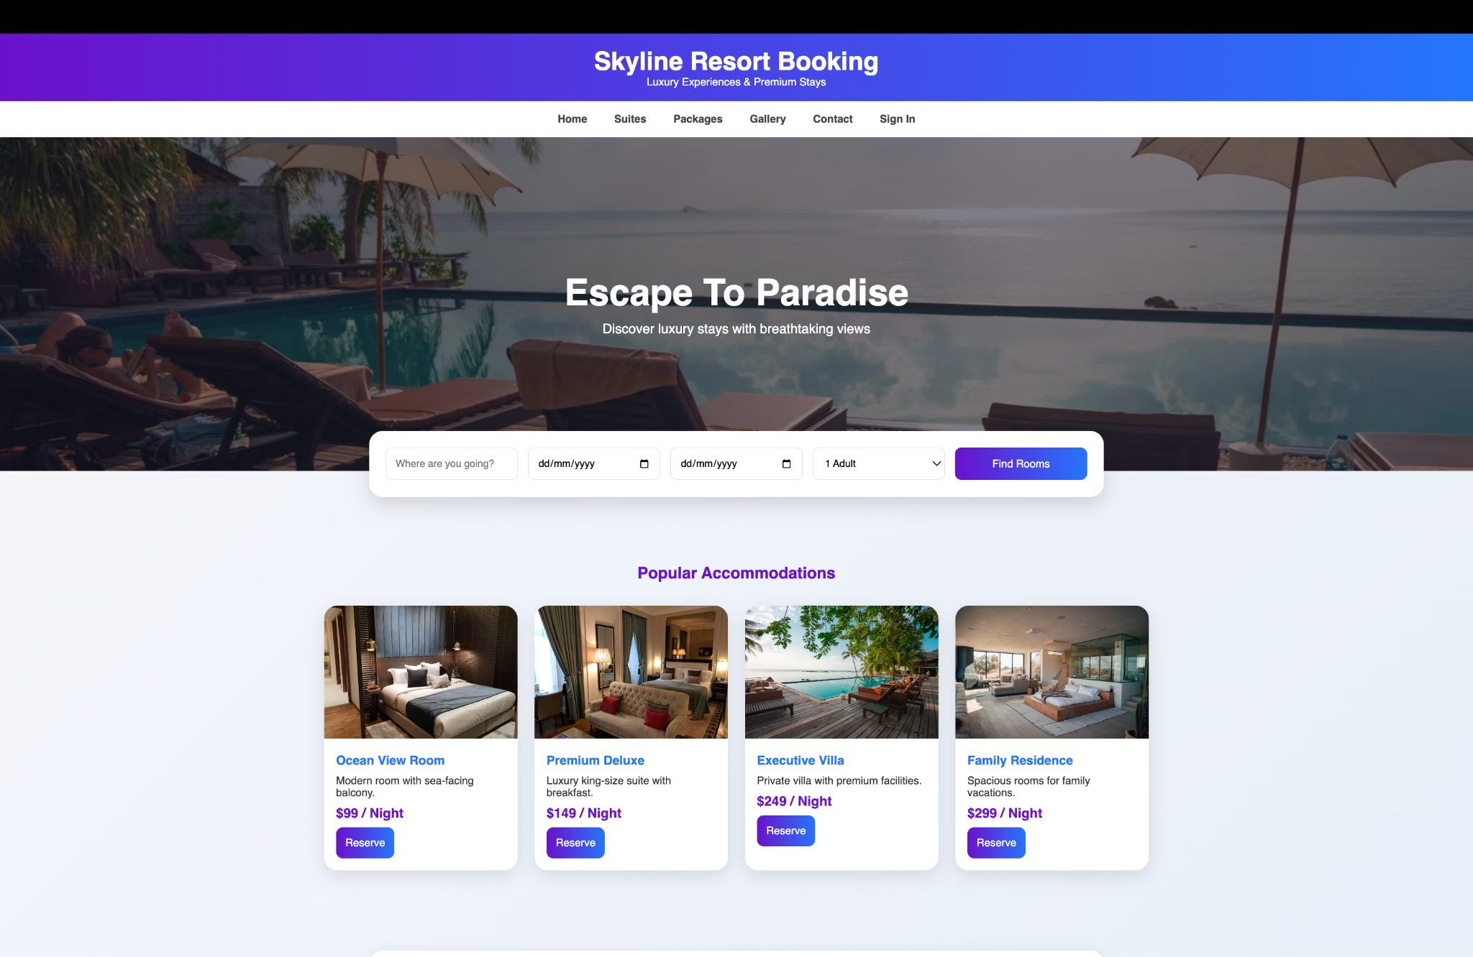

Experiment-3:
<!DOCTYPE html>
<html lang="en">
<head>
<meta charset="UTF-8">
<meta name="viewport" content="width=device-width, initial-scale=1.0">
<title>TransitGo Travel Portal</title>

<style>

*{
margin:0;
padding:0;
box-sizing:border-box;
font-family:'Segoe UI',sans-serif;
}

body{
background:#f8fafc;
color:#333;
}

header{
background:linear-gradient(90deg,#0f172a,#1e293b);
color:white;
padding:20px 40px;
display:flex;
justify-content:space-between;
align-items:center;
}

.logo{
font-size:28px;
font-weight:bold;
}

nav a{
color:white;
text-decoration:none;
margin-left:25px;
font-weight:500;
}

nav a:hover{
color:#38bdf8;
}

.hero{
height:500px;
background:
linear-gradient(rgba(0,0,0,0.5),
rgba(0,0,0,0.5)),
url('https://images.unsplash.com/photo-1544620347-c4fd4a3d5957?auto=format&fit=crop&w=1600&q=80');
background-size:cover;
background-position:center;
display:flex;
justify-content:center;
align-items:center;
text-align:center;
color:white;
}

.hero h1{
font-size:55px;
margin-bottom:15px;
}

.hero p{
font-size:20px;
}

.booking-box{
width:92%;
max-width:1100px;
margin:-60px auto 40px;
background:white;
padding:25px;
border-radius:20px;
box-shadow:0 10px 25px rgba(0,0,0,0.15);
}

.booking-box form{
display:grid;
grid-template-columns:repeat(auto-fit,minmax(180px,1fr));
gap:15px;
}

input,select{
padding:14px;
border:1px solid #ddd;
border-radius:10px;
}

button{
background:#0ea5e9;
color:white;
border:none;
padding:14px;
border-radius:10px;
cursor:pointer;
font-size:16px;
}

button:hover{
background:#0284c7;
}

.section{
padding:60px 40px;
}

.section h2{
text-align:center;
color:#0f172a;
margin-bottom:30px;
}

.cards{
display:flex;
flex-wrap:wrap;
justify-content:center;
gap:25px;
}

.card{
background:white;
width:280px;
padding:25px;
border-radius:20px;
box-shadow:0 5px 20px rgba(0,0,0,0.1);
transition:0.3s;
}

.card:hover{
transform:translateY(-8px);
}

.card h3{
color:#0284c7;
margin-bottom:10px;
}

.info-box{
background:white;
max-width:1100px;
margin:auto;
padding:30px;
border-radius:20px;
box-shadow:0 5px 20px rgba(0,0,0,0.08);
}

.info-box ul{
list-style:none;
}

.info-box li{
padding:10px 0;
}

.feedback{
width:100%;
padding:15px;
border-radius:10px;
border:1px solid #ccc;
}

footer{
background:#0f172a;
color:white;
text-align:center;
padding:25px;
}

</style>
</head>

<body>

<header>
<div class="logo">TransitGo</div>

<nav>
<a href="#">Dashboard</a>
<a href="#">Routes</a>
<a href="#">Schedules</a>
<a href="#">Bookings</a>
<a href="#">Support</a>
<a href="#">Account</a>
</nav>
</header>

<section class="hero">
<div>
<h1>Travel Smarter, Travel Better</h1>
<p>Quick route search and seamless ticket reservations</p>
</div>
</section>

<div class="booking-box">

<form>
<input type="text" placeholder="Departure City">
<input type="text" placeholder="Arrival City">
<input type="date">

<select>
<option>Select Travel Class</option>
<option>Premium</option>
<option>Business</option>
<option>Economy</option>
</select>

<button type="submit">Find Trips</button>
</form>

</div>

<section class="section">

<h2>Popular Travel Options</h2>

<div class="cards">

<div class="card">
<h3>Premium Express</h3>
<p>Luxury seating with onboard Wi-Fi and charging ports.</p>
<p><b>Seats Available: 28</b></p>
<button>Reserve</button>
</div>

<div class="card">
<h3>Night Cruiser</h3>
<p>Comfortable sleeper cabins for overnight journeys.</p>
<p><b>Seats Available: 16</b></p>
<button>Reserve</button>
</div>

<div class="card">
<h3>City Connect</h3>
<p>Fast intercity transportation with multiple departures.</p>
<p><b>Seats Available: 34</b></p>
<button>Reserve</button>
</div>

<div class="card">
<h3>Budget Ride</h3>
<p>Affordable option for daily travelers.</p>
<p><b>Seats Available: 42</b></p>
<button>Reserve</button>
</div>

</div>

</section>

<section class="section">
<div class="info-box">

<h2>Passenger Features</h2>

<ul>
<li>✓ Real-time trip availability</li>
<li>✓ Digital ticket generation</li>
<li>✓ Online reservation management</li>
<li>✓ Travel history tracking</li>
<li>✓ Secure payment processing</li>
<li>✓ Instant booking confirmation</li>
</ul>

</div>
</section>

<section class="section">
<div class="info-box">

<h2>Operations Management</h2>

<ul>
<li>✓ Route administration</li>
<li>✓ Schedule planning</li>
<li>✓ Fleet monitoring</li>
<li>✓ Passenger management</li>
<li>✓ Analytics dashboard</li>
<li>✓ Performance reporting</li>
</ul>

</div>
</section>

<section class="section">
<div class="info-box">

<h2>Traveler Feedback</h2>

<textarea class="feedback" rows="5"
placeholder="Share your travel experience..."></textarea>

<br><br>

<button>Submit Review</button>

</div>
</section>

<section class="section">
<div class="info-box">

<h2>Get In Touch</h2>

<p>📧 help@transitgo.com</p>
<p>📞 +1 (800) 555-1234</p>
<p>📍 Central Transit Hub, Downtown</p>

</div>
</section>

<footer>
<p>© 2026 TransitGo Travel Portal. All Rights Reserved.</p>
</footer>

</body>
</html>

OUT PUT:
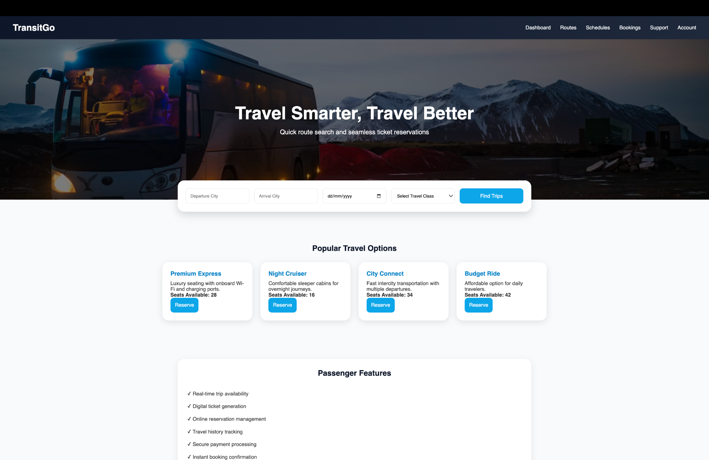

Experiment-4:
<!DOCTYPE html>
<html lang="en">
<head>
<meta charset="UTF-8">
<meta name="viewport" content="width=device-width, initial-scale=1.0">
<title>RailWay Connect Portal</title>

<style>

*{
margin:0;
padding:0;
box-sizing:border-box;
font-family:'Segoe UI',sans-serif;
}

body{
background:#eef2f7;
}

header{
background:linear-gradient(90deg,#1e3a8a,#2563eb);
color:white;
padding:20px 50px;
display:flex;
justify-content:space-between;
align-items:center;
}

.logo{
font-size:30px;
font-weight:bold;
}

nav a{
color:white;
text-decoration:none;
margin-left:25px;
font-weight:500;
}

nav a:hover{
color:#facc15;
}

.hero{
height:500px;
background:
linear-gradient(rgba(0,0,0,0.5),
rgba(0,0,0,0.5)),
url("https://images.unsplash.com/photo-1474487548417-781cb71495f3?auto=format&fit=crop&w=1600&q=80");
background-size:cover;
background-position:center;
display:flex;
justify-content:center;
align-items:center;
text-align:center;
color:white;
}

.hero h1{
font-size:55px;
margin-bottom:15px;
}

.hero p{
font-size:20px;
}

.booking-panel{
width:92%;
max-width:1100px;
margin:-60px auto 40px;
background:white;
padding:25px;
border-radius:20px;
box-shadow:0 10px 25px rgba(0,0,0,0.15);
}

.booking-panel form{
display:grid;
grid-template-columns:repeat(auto-fit,minmax(180px,1fr));
gap:15px;
}

input,select{
padding:14px;
border:1px solid #ccc;
border-radius:10px;
}

button{
background:#2563eb;
color:white;
border:none;
padding:14px;
border-radius:10px;
cursor:pointer;
}

button:hover{
background:#1e40af;
}

.section{
width:92%;
max-width:1200px;
margin:30px auto;
background:white;
padding:30px;
border-radius:20px;
box-shadow:0 5px 15px rgba(0,0,0,0.08);
}

.section h2{
color:#1e3a8a;
margin-bottom:20px;
}

table{
width:100%;
border-collapse:collapse;
}

th{
background:#2563eb;
color:white;
}

th,td{
padding:12px;
border:1px solid #ddd;
text-align:center;
}

.status{
color:green;
font-weight:bold;
}

.cards{
display:flex;
flex-wrap:wrap;
gap:20px;
}

.card{
flex:1;
min-width:250px;
background:#f8fafc;
padding:20px;
border-radius:15px;
border-left:5px solid #2563eb;
}

.card h3{
color:#1e3a8a;
margin-bottom:10px;
}

ul{
padding-left:20px;
}

li{
margin-bottom:10px;
}

footer{
background:#1e3a8a;
color:white;
text-align:center;
padding:25px;
margin-top:40px;
}

</style>
</head>

<body>

<header>
<div class="logo">RailWay Connect</div>

<nav>
<a href="#">Dashboard</a>
<a href="#">Journey Planner</a>
<a href="#">Schedules</a>
<a href="#">My Trips</a>
<a href="#">Support</a>
<a href="#">Account</a>
</nav>
</header>

<section class="hero">
<div>
<h1>Plan Your Next Rail Journey</h1>
<p>Smart Search • Instant Booking • Live Updates</p>
</div>
</section>

<div class="booking-panel">

<form>

<input type="text" placeholder="Departure City">

<input type="text" placeholder="Destination City">

<input type="date">

<select>
<option>Travel Class</option>
<option>Economy</option>
<option>Business</option>
<option>Premium</option>
<option>Executive</option>
</select>

<button type="submit">Find Routes</button>

</form>

</div>

<div class="section">

<h2>Featured Rail Services</h2>

<table>

<tr>
<th>Service ID</th>
<th>Route Name</th>
<th>Departure</th>
<th>Arrival</th>
<th>Status</th>
<th>Action</th>
</tr>

<tr>
<td>RW101</td>
<td>Coastal Express</td>
<td>06:30</td>
<td>13:20</td>
<td class="status">Open</td>
<td><button>Reserve</button></td>
</tr>

<tr>
<td>RW202</td>
<td>Metro Link</td>
<td>09:15</td>
<td>16:00</td>
<td class="status">Open</td>
<td><button>Reserve</button></td>
</tr>

<tr>
<td>RW303</td>
<td>Capital Voyager</td>
<td>11:45</td>
<td>19:30</td>
<td style="color:orange;font-weight:bold;">Limited</td>
<td><button>Reserve</button></td>
</tr>

</table>

</div>

<div class="section">

<h2>Journey Reference Lookup</h2>

<input type="text" placeholder="Enter Journey Reference Number">

<button style="margin-top:15px;">Track Status</button>

</div>

<div class="section">

<h2>Traveler Facilities</h2>

<div class="cards">

<div class="card">
<h3>Digital Booking</h3>
<p>Reserve seats instantly from any device.</p>
</div>

<div class="card">
<h3>Live Tracking</h3>
<p>Get real-time schedule and arrival updates.</p>
</div>

<div class="card">
<h3>E-Ticket Access</h3>
<p>Download and manage travel passes online.</p>
</div>

<div class="card">
<h3>Flexible Changes</h3>
<p>Modify or cancel reservations with ease.</p>
</div>

</div>

</div>

<div class="section">

<h2>Operations Dashboard</h2>

<ul>
<li>Manage service schedules</li>
<li>Monitor seat inventory</li>
<li>Handle passenger accounts</li>
<li>Route planning and updates</li>
<li>Revenue and booking analytics</li>
<li>Travel notifications management</li>
<li>Generate operational reports</li>
<li>Payment monitoring system</li>
</ul>

</div>

<div class="section">

<h2>Contact Information</h2>

<p>📧 support@railwayconnect.com</p>
<br>
<p>📞 +1 (800) 555-7788</p>
<br>
<p>📍 Central Transport Hub, Downtown District</p>

</div>

<footer>
<p>© 2026 RailWay Connect Portal. All Rights Reserved.</p>
</footer>

</body>
</html>

OUTPUT:
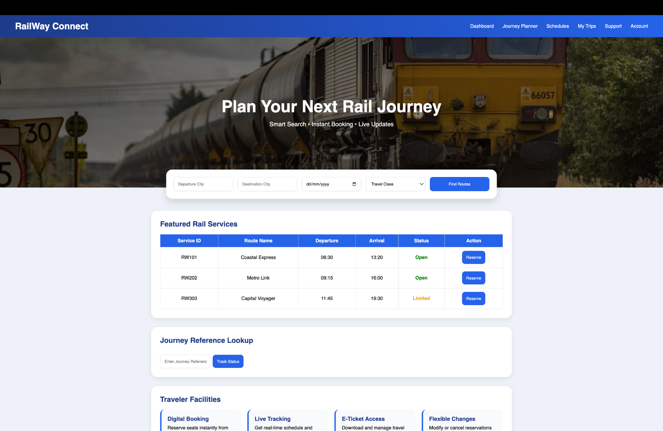
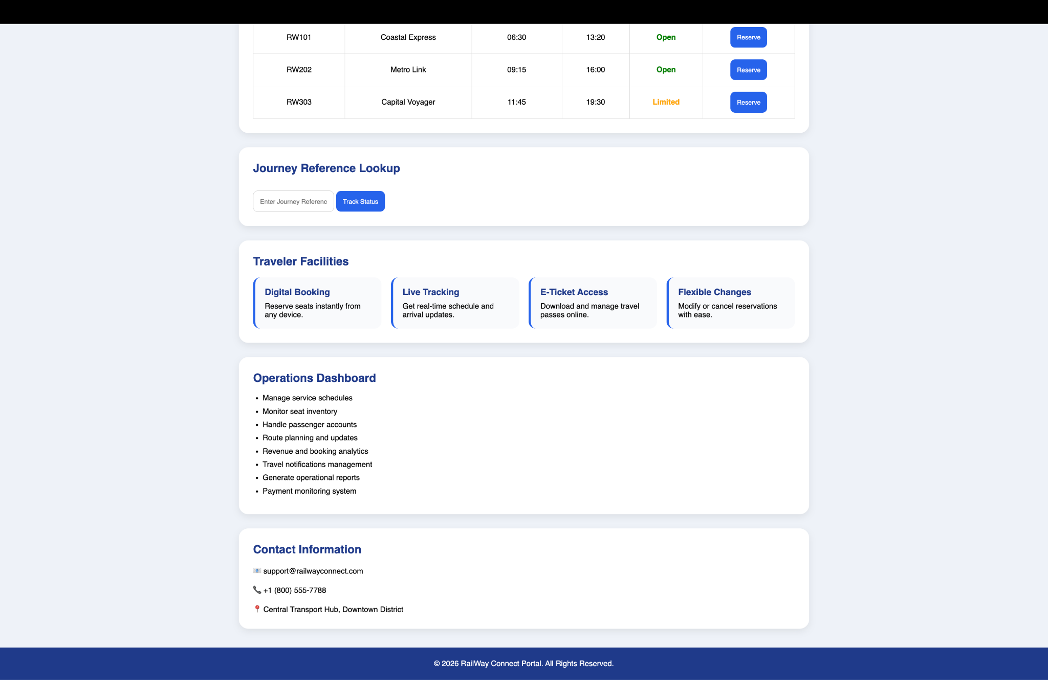

Experiment-5:
<!DOCTYPE html>
<html lang="en">
<head>
<meta charset="UTF-8">
<meta name="viewport" content="width=device-width, initial-scale=1.0">
<title>AeroLink Travel Hub</title>

<style>

*{
margin:0;
padding:0;
box-sizing:border-box;
font-family:'Segoe UI',sans-serif;
}

body{
background:#eef4fa;
color:#333;
}

header{
background:linear-gradient(90deg,#111827,#1e40af);
color:white;
padding:20px 50px;
display:flex;
justify-content:space-between;
align-items:center;
}

.logo{
font-size:30px;
font-weight:bold;
}

nav a{
color:white;
text-decoration:none;
margin-left:25px;
font-weight:500;
}

nav a:hover{
color:#fbbf24;
}

.hero{
height:520px;
background:
linear-gradient(rgba(0,0,0,0.45),
rgba(0,0,0,0.45)),
url("https://images.unsplash.com/photo-1436491865332-7a61a109cc05?auto=format&fit=crop&w=1600&q=80");
background-size:cover;
background-position:center;
display:flex;
justify-content:center;
align-items:center;
text-align:center;
color:white;
}

.hero h1{
font-size:60px;
margin-bottom:15px;
}

.hero p{
font-size:22px;
}

.booking-box{
width:92%;
max-width:1150px;
margin:-70px auto 40px;
background:white;
padding:30px;
border-radius:25px;
box-shadow:0 10px 30px rgba(0,0,0,0.15);
}

.booking-box form{
display:grid;
grid-template-columns:repeat(auto-fit,minmax(180px,1fr));
gap:15px;
}

input,select{
padding:14px;
border:1px solid #d1d5db;
border-radius:12px;
font-size:15px;
}

button{
background:#2563eb;
color:white;
border:none;
padding:14px;
border-radius:12px;
cursor:pointer;
font-size:15px;
transition:0.3s;
}

button:hover{
background:#1d4ed8;
}

.section{
width:92%;
max-width:1200px;
margin:30px auto;
background:white;
padding:30px;
border-radius:20px;
box-shadow:0 5px 15px rgba(0,0,0,0.08);
}

.section h2{
color:#1e3a8a;
margin-bottom:20px;
}

table{
width:100%;
border-collapse:collapse;
}

th{
background:#2563eb;
color:white;
}

th,td{
padding:12px;
border:1px solid #ddd;
text-align:center;
}

.cards{
display:flex;
flex-wrap:wrap;
gap:20px;
}

.card{
flex:1;
min-width:250px;
background:#f8fafc;
padding:20px;
border-radius:15px;
border-left:5px solid #2563eb;
}

.card h3{
color:#1e3a8a;
margin-bottom:10px;
}

.feedback{
width:100%;
padding:15px;
border-radius:10px;
border:1px solid #ccc;
}

footer{
background:#111827;
color:white;
text-align:center;
padding:25px;
margin-top:40px;
}

</style>
</head>

<body>

<header>
<div class="logo">AeroLink</div>

<nav>
<a href="#">Home</a>
<a href="#">Destinations</a>
<a href="#">Trips</a>
<a href="#">Offers</a>
<a href="#">Support</a>
<a href="#">Account</a>
</nav>
</header>

<section class="hero">
<div>
<h1>Explore The World Above</h1>
<p>Premium Air Travel Made Simple</p>
</div>
</section>

<div class="booking-box">

<form>

<input type="text" placeholder="Departure City">

<input type="text" placeholder="Arrival City">

<input type="date">

<select>
<option>Travel Cabin</option>
<option>Economy</option>
<option>Premium</option>
<option>Business</option>
<option>Luxury Suite</option>
</select>

<button type="submit">Find Flights</button>

</form>

</div>

<div class="section">

<h2>Featured Air Routes</h2>

<table>

<tr>
<th>Route ID</th>
<th>Carrier</th>
<th>Takeoff</th>
<th>Landing</th>
<th>Availability</th>
<th>Fare</th>
<th>Action</th>
</tr>

<tr>
<td>AL102</td>
<td>SkyConnect Airways</td>
<td>07:15</td>
<td>09:45</td>
<td>32 Seats</td>
<td>$210</td>
<td><button>Reserve</button></td>
</tr>

<tr>
<td>AL204</td>
<td>BlueWing Airlines</td>
<td>11:00</td>
<td>13:25</td>
<td>20 Seats</td>
<td>$185</td>
<td><button>Reserve</button></td>
</tr>

<tr>
<td>AL308</td>
<td>GlobalJet</td>
<td>17:40</td>
<td>20:05</td>
<td>12 Seats</td>
<td>$245</td>
<td><button>Reserve</button></td>
</tr>

</table>

</div>

<div class="section">

<h2>Traveler Benefits</h2>

<div class="cards">

<div class="card">
<h3>Digital Boarding</h3>
<p>Access mobile boarding passes instantly.</p>
</div>

<div class="card">
<h3>Live Flight Updates</h3>
<p>Receive real-time departure notifications.</p>
</div>

<div class="card">
<h3>Secure Payments</h3>
<p>Protected transactions and booking security.</p>
</div>

<div class="card">
<h3>Flexible Changes</h3>
<p>Manage reservations from your dashboard.</p>
</div>

</div>

</div>

<div class="section">

<h2>Operations Center</h2>

<ul>
<li>Flight schedule management</li>
<li>Passenger account administration</li>
<li>Seat inventory monitoring</li>
<li>Fare management system</li>
<li>Travel analytics dashboard</li>
<li>Booking and payment tracking</li>
<li>Report generation tools</li>
<li>Customer support management</li>
</ul>

</div>

<div class="section">

<h2>Share Your Experience</h2>

<textarea class="feedback" rows="6"
placeholder="Tell us about your journey experience..."></textarea>

<br><br>

<button>Send Review</button>

</div>

<div class="section">

<h2>Reach Our Team</h2>

<p>📧 care@aerolinktravel.com</p>
<br>

<p>📞 +1 (800) 555-8899</p>
<br>

<p>📍 AeroLink Travel Center, International Gateway District</p>

</div>

<footer>

<p>© 2026 AeroLink Travel Hub. All Rights Reserved.</p>

</footer>

</body>
</html>

OUTPUT:
